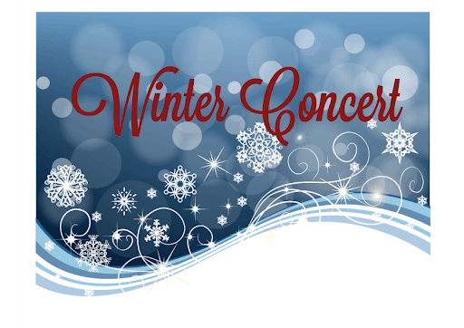

Links

**SESSION 1**

**FRIDAY, DEC. 17:  ROBERT C. DODSON CONCERTS!**

**8:30-9:30 AM:**

PK1, PK2, 1-1, 1-2, 2-1, 2-4,

3-1, 3-3, 4-2, 5-1, 5-2

[Dodson Winter Concert Session 1 Link](https://teams.microsoft.com/l/meetup-join/19%3ameeting_MzlkOTdmYzEtMGNmMC00OTA5LTkxY2YtOTczYjJkNTc4YzJh%40thread.v2/0?context=%7b%22Tid%22%3a%229f256e05-cd04-4e8a-a28b-11b2324a97d4%22%2c%22Oid%22%3a%227e18eff8-ef4e-4827-8718-24b13c97e1de%22%2c%22IsBroadcastMeeting%22%3atrue%7d&btype=a&role=a)

**\*\*\*\*\*\*\*\*\*\*\*\*\*\*\*\*\*\*\*\*\*\*\*\*\*\*\*\*\*\*\*\*\*\*\*\*\*\*\*\*\*\*\*\*\*\*\*\*\*\*\*\*\*\*\*\*\*\*\*\*\*\*\*\*\*\*\*\*\*\*\*\*\*\*\*\*\*\*\*\*\*\*\*\*\*\*\*\*\*\*\*\*\*\*\*\*\*\*\*\*\*\*\*\*\*\*\*\*\***

**SESSION 2**

**FRIDAY, DEC. 17:  ROBERT C. DODSON CONCERTS!**

**12:30-1:30 PM:**

K-2, K-3, 1-3, 2-2, 2-3, 3-2,

4-3, 4-4, 5-3, 5-4

[Dodson Winter Concert Session II Link](https://teams.microsoft.com/l/meetup-join/19%3ameeting_M2U2MDMxMjgtMmRlMS00ZTFkLTg5MTItMGM1OGNjYjRjYjhm%40thread.v2/0?context=%7b%22Tid%22%3a%229f256e05-cd04-4e8a-a28b-11b2324a97d4%22%2c%22Oid%22%3a%227e18eff8-ef4e-4827-8718-24b13c97e1de%22%2c%22IsBroadcastMeeting%22%3atrue%7d&btype=a&role=a)